**符昕宇 202364810311**

**To access my code more easily, you can find them at my github repository:**

**https://github.com/Fluorine-Brian/Code-for-Digital-Image-Processing**

**Homework1: Implement Figure 4.40 by programming with Python**

**Python Code:**

**import** numpy as np

**import** imageio.v2 as imageio

**import** matplotlib

**import** matplotlib.pyplot as plt

**import** os

**def** pad_image_for_dft(image):

    """

    Pads the image to a size suitable for DFT

    """

    M, N **=** image.shape

    P, Q **=** 2 **\*** M, 2 **\*** N

    padded_image **=** np.zeros((P, Q), dtype**=**image.dtype)

    padded_image[0:M, 0:N] **=** image

**return** padded_image, (M, N)

**def** calculate_power_percentage(centered_dft_spectrum, D0):

    """

    Calculates the percentage of total power contained within a circle of radius D0

    """

    P, Q **=** centered_dft_spectrum.shape

    power_spectrum **=** np.abs(centered_dft_spectrum) **\*\*** 2

    total_power **=** np.sum(power_spectrum)

    power_within_D0 **=** 0.0

    center_u, center_v **=** P **/** 2, Q **/** 2

    u_coords **=** np.arange(P) **-** P **/** 2

    v_coords **=** np.arange(Q) **-** Q **/** 2

    U, V **=** np.meshgrid(u_coords, v_coords, indexing**=**'ij')

    D_uv **=** np.sqrt(U **\*\*** 2 **+** V **\*\*** 2)

    power_within_D0 **=** np.sum(power_spectrum[D_uv <**=** D0])

**if** total_power > 0:

**return** (power_within_D0 **/** total_power) **\*** 100

**else**:

**return** 0.0

**if** __name__ **==** "__main__":

    input_dir **=** "original_image"

    output_dir **=** "output_image"

    os.makedirs(output_dir, exist_ok**=**True)

    image_filename **=** "Fig0440.tif"

    image_path **=** os.path.join(input_dir, image_filename)

    base_name **=** os.path.splitext(image_filename)[0]

    original_image **=** imageio.imread(image_path)

    original_M, original_N **=** original_image.shape

    padded_image, _ **=** pad_image_for_dft(original_image)

    P, Q **=** padded_image.shape

    dft_original **=** np.fft.fft2(padded_image.astype(float))

    centered_dft **=** np.fft.fftshift(dft_original)

    spectrum_log_magnitude **=** 20 **\*** np.log(np.abs(centered_dft) **+** 1e**-**9)

    spectrum_display **=** (spectrum_log_magnitude **-** np.min(spectrum_log_magnitude)) **/**

                       (np.max(spectrum_log_magnitude) **-** np.min(spectrum_log_magnitude)) **\*** 255

    spectrum_display **=** spectrum_display.astype(np.uint8)

    D0_values **=** [10, 30, 60, 160, 460]

    power_percentages **=** {}

**for** D0 **in** D0_values:

        power_percent **=** calculate_power_percentage(centered_dft, D0)

        power_percentages[D0] **=** power_percent

    plt.figure(figsize**=**(14, 7))

    plt.suptitle(f'Figure 4.40: Test Pattern and its Frequency Spectrum for {image_filename}', fontsize**=**16)

    plt.subplot(1, 2, 1)

    plt.imshow(original_image, cmap**=**'gray', vmin**=**0, vmax**=**255)

    plt.title('a) Test Pattern Image')

    plt.axis('off')

    plt.subplot(1, 2, 2)

    plt.imshow(spectrum_display, cmap**=**'gray', vmin**=**0, vmax**=**255)

    plt.title('b) Frequency Spectrum with D0 Circles')

    plt.axis('off')

    center_x, center_y **=** Q **/** 2, P **/** 2

**for** D0 **in** D0_values:

        circle **=** plt.Circle((center_x, center_y), D0, color**=**'red', fill**=**False, linewidth**=**1, alpha**=**0.7)

        plt.gca().add_patch(circle)

        text_x **=** center_x **+** D0 **\*** np.cos(np.deg2rad(45))center

        text_y **=** center_y **+** D0 **\*** np.sin(np.deg2rad(45))

    plt.tight_layout(rect**=**[0, 0.03, 1, 0.95])

    combined_output_path **=** os.path.join(output_dir, f"{base_name}_fig4_40_reproduction.png")

    plt.savefig(combined_output_path, bbox_inches**=**'tight')

    plt.close()

**Processed Images:**

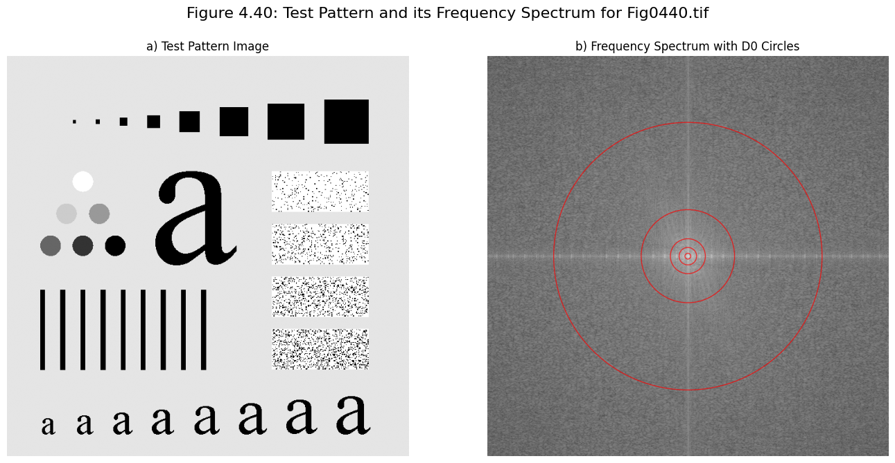

**Homework 2: Implement Figure 4.41 by programming with Python**

**Python Code:**

**import** numpy as np

**import** imageio.v2 as imageio

**import** matplotlib.pyplot as plt

**import** os

**def** pad_image_for_dft(image):

    """

    Pads the image to a size suitable for DFT (e.g., 2*M x 2*N)

    """

    M, N **=** image.shape

    P, Q **=** 2 **\*** M, 2 **\*** N  # Double the dimensions

    padded_image **=** np.zeros((P, Q), dtype**=**image.dtype)

    padded_image[0:M, 0:N] **=** image

**return** padded_image, (M, N)

**def** calculate_power_percentage(centered_dft_spectrum, D0):

    """

    Calculates the percentage of total power contained within a circle of radius D0

    """

    P, Q **=** centered_dft_spectrum.shape

    power_spectrum **=** np.abs(centered_dft_spectrum) **\*\*** 2

    total_power **=** np.sum(power_spectrum)

    power_within_D0 **=** 0.0

    center_u, center_v **=** P **/** 2, Q **/** 2

    u_coords **=** np.arange(P) **-** P **/** 2

    v_coords **=** np.arange(Q) **-** Q **/** 2

    U, V **=** np.meshgrid(u_coords, v_coords, indexing**=**'ij')

    D_uv **=** np.sqrt(U **\*\*** 2 **+** V **\*\*** 2)

    power_within_D0 **=** np.sum(power_spectrum[D_uv <**=** D0])

**if** total_power > 0:

**return** (power_within_D0 **/** total_power) **\*** 100

**else**:

**return** 0.0

**if** __name__ **==** "__main__":

    input_dir **=** "original_image"

    output_dir **=** "output_image"

    os.makedirs(output_dir, exist_ok**=**True)

    image_filename **=** "Fig0440.tif"

    image_path **=** os.path.join(input_dir, image_filename)

    base_name **=** os.path.splitext(image_filename)[0]

    original_image **=** imageio.imread(image_path)

    original_M, original_N **=** original_image.shape

    padded_image, _ **=** pad_image_for_dft(original_image)

    P, Q **=** padded_image.shape

    dft_original **=** np.fft.fft2(padded_image.astype(float))

    centered_dft **=** np.fft.fftshift(dft_original)

    spectrum_log_magnitude **=** 20 **\*** np.log(np.abs(centered_dft) **+** 1e**-**9)

    spectrum_display **=** (spectrum_log_magnitude **-** np.min(spectrum_log_magnitude)) **/** \

                       (np.max(spectrum_log_magnitude) **-** np.min(spectrum_log_magnitude)) **\*** 255

    spectrum_display **=** spectrum_display.astype(np.uint8)

    D0_values **=** [10, 30, 60, 160, 460]

    power_percentages **=** {}

**for** D0 **in** D0_values:

        power_percent **=** calculate_power_percentage(centered_dft, D0)

        power_percentages[D0] **=** power_percent

    plt.figure(figsize**=**(14, 7))

    plt.suptitle(f'Figure 4.40: Test Pattern and its Frequency Spectrum for {image_filename}', fontsize**=**16)

    plt.subplot(1, 2, 1)

    plt.imshow(original_image, cmap**=**'gray', vmin**=**0, vmax**=**255)

    plt.title('a) Test Pattern Image')

    plt.axis('off')

    plt.subplot(1, 2, 2)

    plt.imshow(spectrum_display, cmap**=**'gray', vmin**=**0, vmax**=**255)

    plt.title('b) Frequency Spectrum with D0 Circles')

    plt.axis('off')

    center_x, center_y **=** Q **/** 2, P **/** 2

**for** D0 **in** D0_values:

        circle **=** plt.Circle((center_x, center_y), D0, color**=**'red', fill**=**False, linewidth**=**1, alpha**=**0.7)

        plt.gca().add_patch(circle)

        text_x **=** center_x **+** D0 **\*** np.cos(np.deg2rad(45))

        text_y **=** center_y **+** D0 **\*** np.sin(np.deg2rad(45))

    plt.tight_layout(rect**=**[0, 0.03, 1, 0.95])

    combined_output_path **=** os.path.join(output_dir, f"{base_name}_fig4_40_reproduction.png")

    plt.savefig(combined_output_path, bbox_inches**=**'tight')

    plt.close()

**Processed Images:**

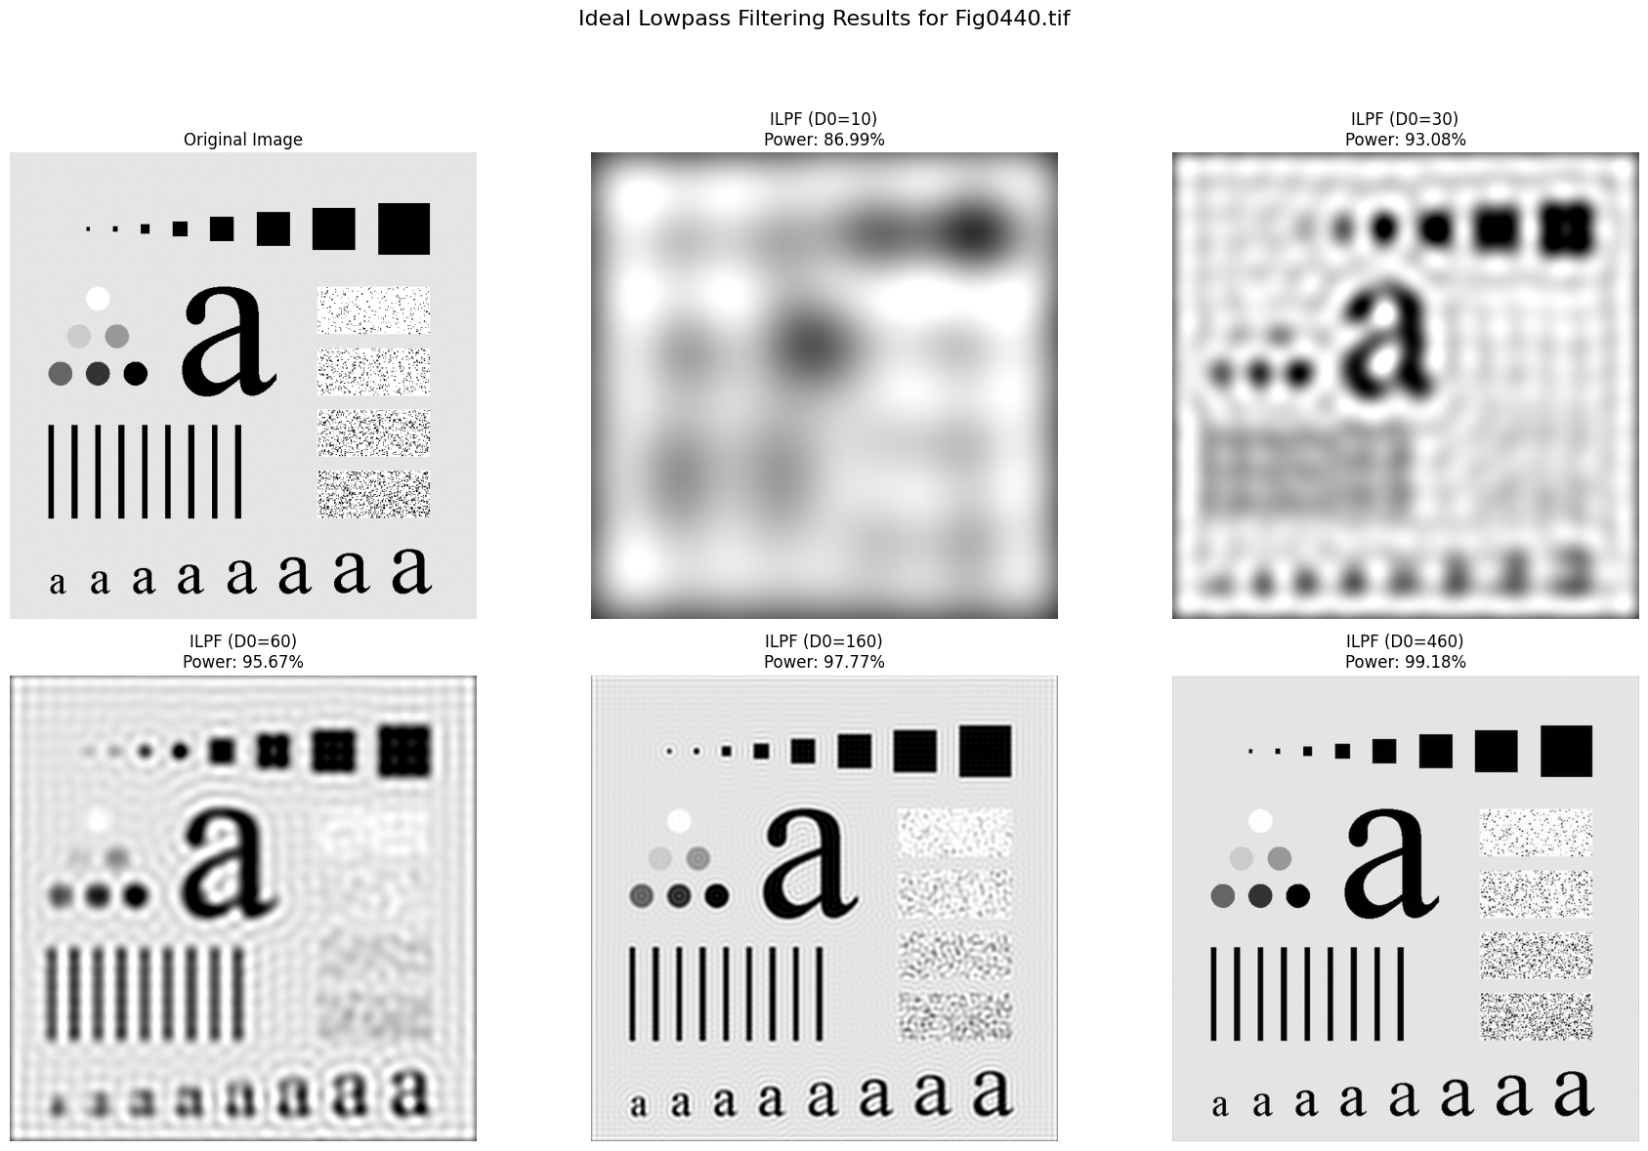

**Homework3: Implement Figure 4.44 by programming with Python**

**Python Code:**

**import** numpy as np

**import** imageio.v2 as imageio

**import** matplotlib

**import** matplotlib.pyplot as plt

**import** os

**def** pad_image_for_dft(image, padding_mode**=**'reflect'):

    """

    Pads the image to a size suitable for DFT (e.g., 2*M x 2*N)

    """

    M, N **=** image.shape

    P, Q **=** 2 **\*** M, 2 **\*** N

    pad_h **=** P **-** M

    pad_w **=** Q **-** N

    padded_image **=** np.pad(image, ((0, pad_h), (0, pad_w)), mode**=**padding_mode)

**return** padded_image, (M, N)

**def** create_gaussian_lowpass_filter(shape, D0):

    """

    Creates a Gaussian Lowpass Filter (GLPF) in the frequency domain

    """

    P, Q **=** shape

    H **=** np.zeros((P, Q), dtype**=**float)

    center_u, center_v **=** P **/** 2, Q **/** 2

    u_coords **=** np.arange(P) **-** center_u

    v_coords **=** np.arange(Q) **-** center_v

    U, V **=** np.meshgrid(u_coords, v_coords, indexing**=**'ij')

    D_uv_squared **=** U **\*\*** 2 **+** V **\*\*** 2

**if** D0 **==** 0:

        H **=** np.ones(shape, dtype**=**float)

**else**:

        H **=** np.exp(**-**D_uv_squared **/** (2 **\*** D0 **\*\*** 2))

**return** H

**if** __name__ **==** "__main__":

    input_dir **=** "original_image"

    output_dir **=** "output_image"

    os.makedirs(output_dir, exist_ok**=**True)

    image_filename **=** "Fig0440.tif"

    image_path **=** os.path.join(input_dir, image_filename)

    base_name **=** os.path.splitext(image_filename)[0]

    original_image **=** imageio.imread(image_path)

    original_M, original_N **=** original_image.shape

    padded_image, _ **=** pad_image_for_dft(original_image, padding_mode**=**'reflect')

    P, Q **=** padded_image.shape

    dft_original **=** np.fft.fft2(padded_image.astype(float))

    centered_dft **=** np.fft.fftshift(dft_original)

    D0_values **=** [10, 30, 60, 160, 460]

    filtered_images **=** {}

**for** D0 **in** D0_values:

        H **=** create_gaussian_lowpass_filter((P, Q), D0)

        filtered_dft **=** centered_dft **\*** H

        idft_shifted **=** np.fft.ifftshift(filtered_dft)

        filtered_image_complex **=** np.fft.ifft2(idft_shifted)

        filtered_image **=** np.real(filtered_image_complex)[0:original_M, 0:original_N]

        filtered_image **=** np.clip(filtered_image, 0, 255).astype(np.uint8)

        filtered_images[D0] **=** filtered_image

    plt.figure(figsize**=**(18, 12))

    plt.suptitle(f'Gaussian Lowpass Filtering Results for {image_filename}', fontsize**=**16)

    plt.subplot(2, 3, 1)

    plt.imshow(original_image, cmap**=**'gray', vmin**=**0, vmax**=**255)

    plt.title('a) Original Image')

    plt.axis('off')

    subplot_labels **=** ['b', 'c', 'd', 'e', 'f']

**for** i, D0 **in** enumerate(D0_values):

        plt.subplot(2, 3, i **+** 2)

        plt.imshow(filtered_images[D0], cmap**=**'gray', vmin**=**0, vmax**=**255)

        plt.title(f'{subplot_labels[i]}) GLPF (D0={D0})')

        plt.axis('off')

    plt.tight_layout(rect**=**[0, 0.03, 1, 0.95])

    combined_output_path **=** os.path.join(output_dir, f"{base_name}_glpf_results_combined.png")

    plt.savefig(combined_output_path, bbox_inches**=**'tight')

    plt.close()

**Processed Images:**

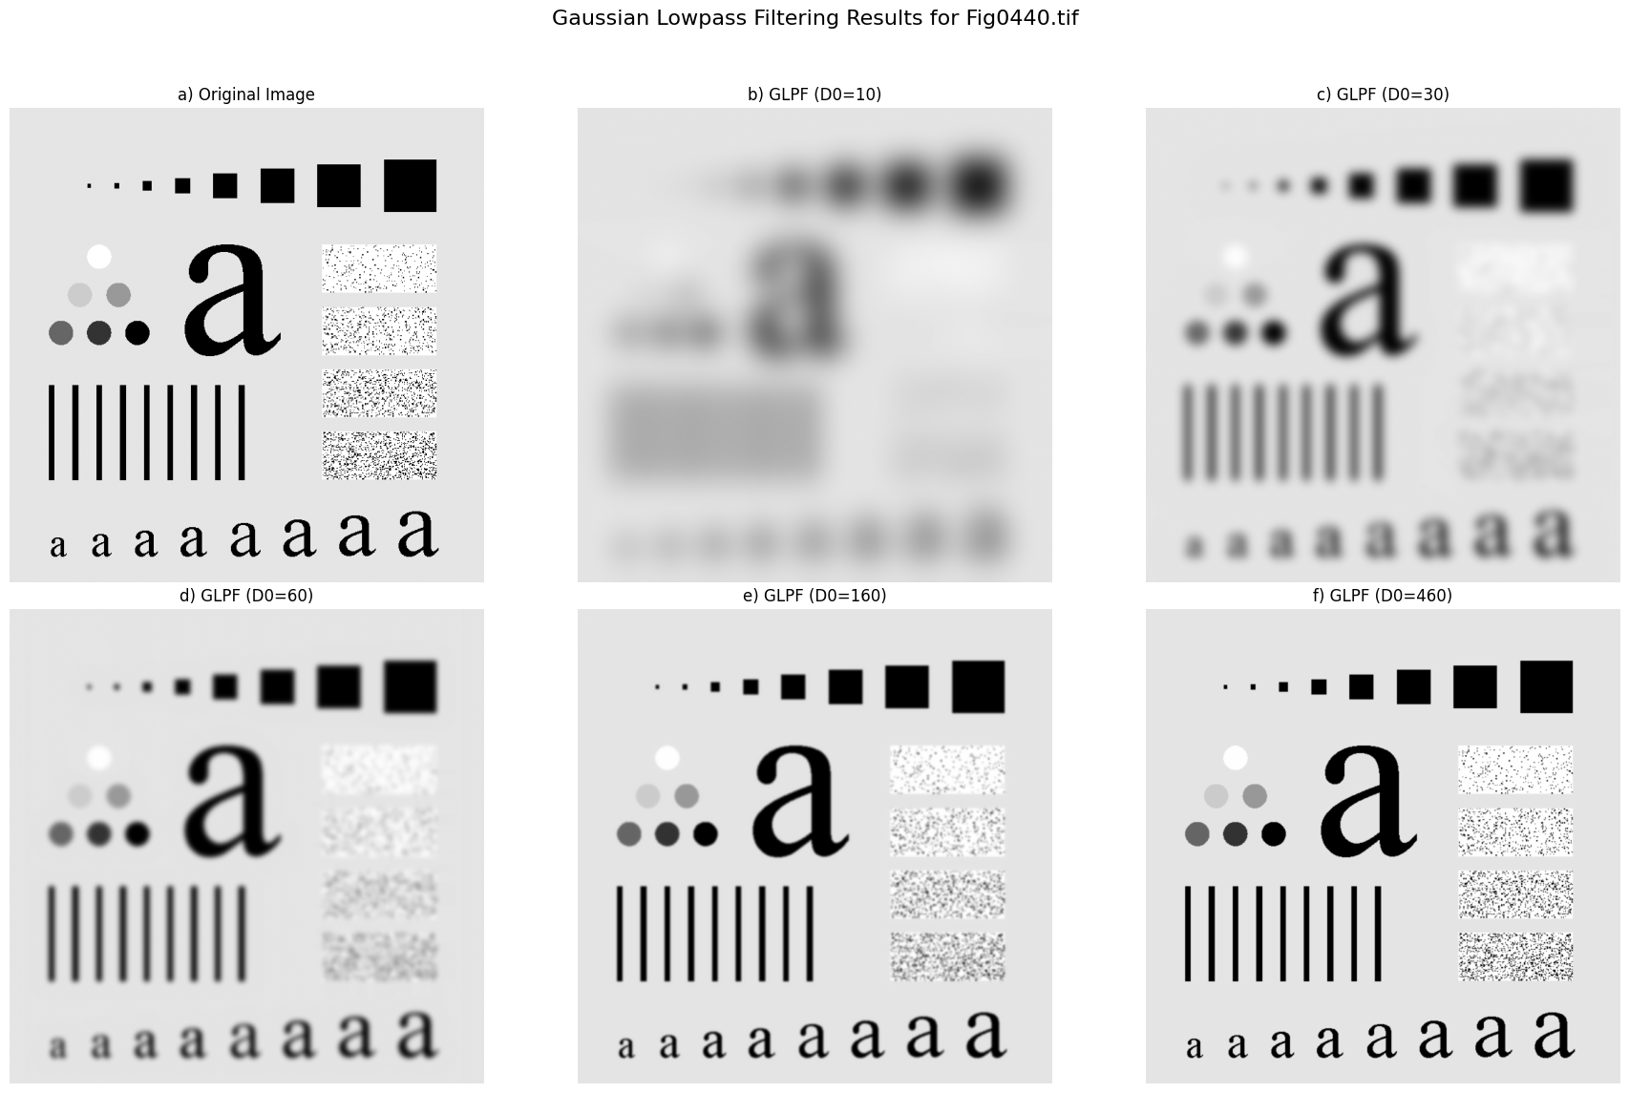

**Homework4: Implement Figure 4.46 by programming with Python**

**Python Code:**

**import** numpy as np

**import** imageio.v2 as imageio

**import** matplotlib

**import** matplotlib.pyplot as plt

**import** os

**def** pad_image_for_dft(image, padding_mode**=**'reflect'):

    """

    Pads the image to a size suitable for DFT (e.g., 2*M x 2*N)

    """

    M, N **=** image.shape

    P, Q **=** 2 **\*** M, 2 **\*** N

    pad_h **=** P **-** M

    pad_w **=** Q **-** N

    padded_image **=** np.pad(image, ((0, pad_h), (0, pad_w)), mode**=**padding_mode)

**return** padded_image, (M, N)

**def** create_butterworth_lowpass_filter(shape, D0, n):

    """

    Creates a Butterworth Lowpass Filter (BLPF) in the frequency domain

    """

    P, Q **=** shape

    H **=** np.zeros((P, Q), dtype**=**float)

    center_u, center_v **=** P **/** 2, Q **/** 2

    u_coords **=** np.arange(P) **-** center_u

    v_coords **=** np.arange(Q) **-** center_v

    U, V **=** np.meshgrid(u_coords, v_coords, indexing**=**'ij')

    D_uv **=** np.sqrt(U **\*\*** 2 **+** V **\*\*** 2)

**if** D0 **==** 0:

        H **=** np.ones(shape, dtype**=**float)  # Pass all frequencies if D0 is 0

**else**:

        H **=** 1 **/** (1 **+** (D_uv **/** D0) **\*\*** (2 **\*** n))

        H[int(center_u), int(center_v)] **=** 1.0

**return** H

**if** __name__ **==** "__main__":

    input_dir **=** "original_image"

    output_dir **=** "output_image"

    os.makedirs(output_dir, exist_ok**=**True)

    image_filename **=** "Fig0440.tif"

    image_path **=** os.path.join(input_dir, image_filename)

    base_name **=** os.path.splitext(image_filename)[0]

    original_image

    original_M, original_N **=** original_image.shape

    padded_image, _ **=** pad_image_for_dft(original_image, padding_mode**=**'reflect')

    P, Q **=** padded_image.shape

    dft_original **=** np.fft.fft2(padded_image.astype(float))

    centered_dft **=** np.fft.fftshift(dft_original)

    D0_values **=** [10, 30, 60, 160, 460]

    n_order **=** 2.25

    filtered_images **=** {}

**for** D0 **in** D0_values:

        H **=** create_butterworth_lowpass_filter((P, Q), D0, n_order)

        filtered_dft **=** centered_dft **\*** H

        idft_shifted **=** np.fft.ifftshift(filtered_dft)

        filtered_image_complex **=** np.fft.ifft2(idft_shifted)

        filtered_image **=** np.real(filtered_image_complex)[0:original_M, 0:original_N]

        filtered_image **=** np.clip(filtered_image, 0, 255).astype(np.uint8)

        filtered_images[D0] **=** filtered_image

    plt.figure(figsize**=**(18, 12))

    plt.suptitle(f'Butterworth Lowpass Filtering Results for {image_filename} (n={n_order})', fontsize**=**16)

    plt.subplot(2, 3, 1)

    plt.imshow(original_image, cmap**=**'gray', vmin**=**0, vmax**=**255)

    plt.title('a) Original Image')

    plt.axis('off')

    subplot_labels **=** ['b', 'c', 'd', 'e', 'f']

**for** i, D0 **in** enumerate(D0_values):

        plt.subplot(2, 3, i **+** 2)

        plt.imshow(filtered_images[D0], cmap**=**'gray', vmin**=**0, vmax**=**255)

        plt.title(f'{subplot_labels[i]}) BLPF (D0={D0}, n={n_order})')

        plt.axis('off')

    plt.tight_layout(rect**=**[0, 0.03, 1, 0.95])

    combined_output_path **=** os.path.join(output_dir, f"{base_name}_blpf_results_combined_n{n_order}.png")

    plt.savefig(combined_output_path, bbox_inches**=**'tight')

    plt.close()

**Processed Image**

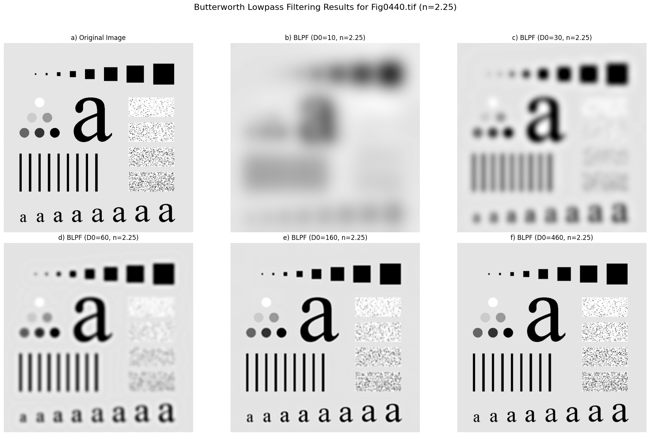

**Homework5: Implement Figure 4.48 by programming with Python**

**Python Code:**

**import** numpy as np

**import** imageio.v2 as imageio

**import** matplotlib.pyplot as plt

**import** os

**def** pad_image_for_dft(image, padding_mode**=**'reflect'):

    """

    Pads the image to a size suitable for DFT (e.g., 2*M x 2*N)

    """

    M, N **=** image.shape

    P, Q **=** 2 **\*** M, 2 **\*** N

    pad_h **=** P **-** M

    pad_w **=** Q **-** N

    padded_image **=** np.pad(image, ((0, pad_h), (0, pad_w)), mode**=**padding_mode)

**return** padded_image, (M, N)

**def** create_gaussian_lowpass_filter(shape, D0):

    """

    Creates a Gaussian Lowpass Filter (GLPF) in the frequency domain

    """

    P, Q **=** shape

    H **=** np.zeros((P, Q), dtype**=**float)

    center_u, center_v **=** P **/** 2, Q **/** 2

    u_coords **=** np.arange(P) **-** center_u

    v_coords **=** np.arange(Q) **-** center_v

    U, V **=** np.meshgrid(u_coords, v_coords, indexing**=**'ij')

    D_uv_squared **=** U **\*\*** 2 **+** V **\*\*** 2

**if** D0 **==** 0:

        H **=** np.ones(shape, dtype**=**float)

**else**:

        H **=** np.exp(**-**D_uv_squared **/** (2 **\*** D0 **\*\*** 2))

**return** H

**if** __name__ **==** "__main__":

    input_dir **=** "original_image"

    output_dir **=** "output_image"

    os.makedirs(output_dir, exist_ok**=**True)

    image_filename **=** "Fig0419(a)(text_gaps_of_1_and_2_pixels).tif"

    image_path **=** os.path.join(input_dir, image_filename)

    base_name **=** os.path.splitext(image_filename)[0]

    original_image **=** imageio.imread(image_path)

    original_M, original_N **=** original_image.shape

    padded_image, _ **=** pad_image_for_dft(original_image, padding_mode**=**'reflect')

    P, Q **=** padded_image.shape

    dft_original **=** np.fft.fft2(padded_image.astype(float))

    centered_dft **=** np.fft.fftshift(dft_original)

    D0_value **=** 120

    H **=** create_gaussian_lowpass_filter((P, Q), D0_value)

    filtered_dft **=** centered_dft **\*** H

    idft_shifted **=** np.fft.ifftshift(filtered_dft)

    filtered_image_complex **=** np.fft.ifft2(idft_shifted)

    filtered_image **=** np.real(filtered_image_complex)[0:original_M, 0:original_N]

    filtered_image **=** np.clip(filtered_image, 0, 255).astype(np.uint8)

    print(f"Finished GLPF with D0={D0_value}.")

    plt.figure(figsize**=**(12, 6))

    plt.suptitle(f'Text Gap Repair using GLPF for {image_filename}', fontsize**=**16)

    plt.subplot(1, 2, 1)

    plt.imshow(original_image, cmap**=**'gray', vmin**=**0, vmax**=**255)

    plt.title('a) Original Text with Gaps')

    plt.axis('off')

    plt.subplot(1, 2, 2)

    plt.imshow(filtered_image, cmap**=**'gray', vmin**=**0, vmax**=**255)

    plt.title(f'b) GLPF Filtered (D0={D0_value})')

    plt.axis('off')

    plt.tight_layout(rect**=**[0, 0.03, 1, 0.95])

    combined_output_path **=** os.path.join(output_dir, f"{base_name}_glpf_text_repair_results.png")

    plt.savefig(combined_output_path, bbox_inches**=**'tight')

    plt.close()

**Processed Images:**

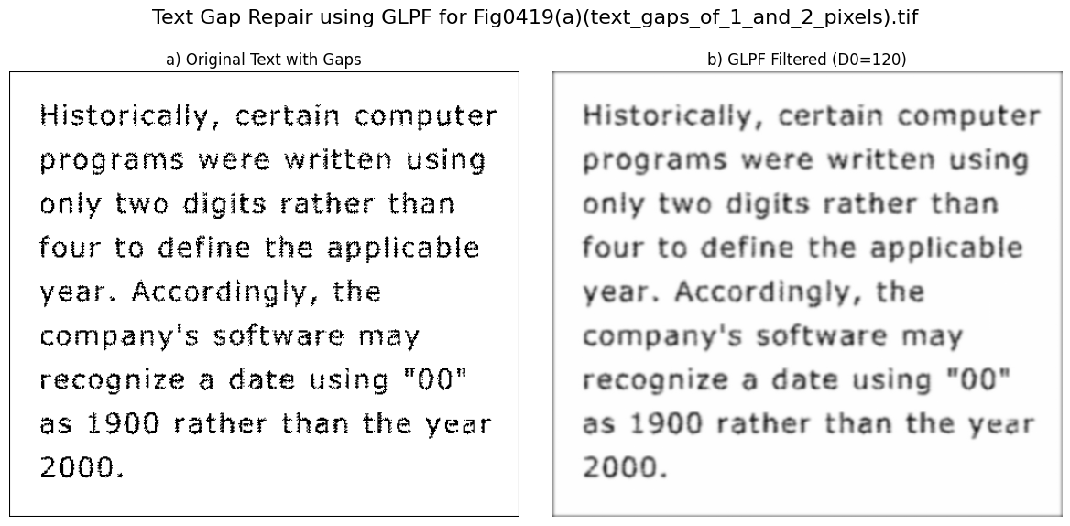



**Homework6: Implement Figure 4.49 by programming with Python**

**Python Code:**

**import** numpy as np

**import** imageio.v2 as imageio

**import** matplotlib.pyplot as plt

**import** os

**def** pad_image_for_dft(image, padding_mode**=**'reflect'):

    """

    Pads the image to a size suitable for DFT (e.g., 2*M x 2*N)

    """

    M, N **=** image.shape

    P, Q **=** 2 **\*** M, 2 **\*** N

    pad_h **=** P **-** M

    pad_w **=** Q **-** N

    padded_image **=** np.pad(image, ((0, pad_h), (0, pad_w)), mode**=**padding_mode)

**return** padded_image, (M, N)

**def** create_gaussian_lowpass_filter(shape, D0):

    """

    Creates a Gaussian Lowpass Filter (GLPF) in the frequency domain

    """

    P, Q **=** shape

    H **=** np.zeros((P, Q), dtype**=**float)

    center_u, center_v **=** P **/** 2, Q **/** 2

    u_coords **=** np.arange(P) **-** center_u

    v_coords **=** np.arange(Q) **-** center_v

    U, V **=** np.meshgrid(u_coords, v_coords, indexing**=**'ij')

    D_uv_squared **=** U **\*\*** 2 **+** V **\*\*** 2

**if** D0 **==** 0:

        H **=** np.ones(shape, dtype**=**float)

**else**:

        H **=** np.exp(**-**D_uv_squared **/** (2 **\*** D0 **\*\*** 2))

**return** H

**if** __name__ **==** "__main__":

    input_dir **=** "original_image"

    output_dir **=** "output_image"

    os.makedirs(output_dir, exist_ok**=**True)exist

    image_filename **=** "Fig0450(a)(woman_original).tif"

    image_path **=** os.path.join(input_dir, image_filename)

    base_name **=** os.path.splitext(image_filename)[0]

    original_image **=** imageio.imread(image_path)

    original_M, original_N **=** original_image.shape

    padded_image, _ **=** pad_image_for_dft(original_image, padding_mode**=**'reflect')

    P, Q **=** padded_image.shape

    dft_original **=** np.fft.fft2(padded_image.astype(float))

    centered_dft **=** np.fft.fftshift(dft_original)

    D0_values **=** [150, 130]

    filtered_images **=** {}

**for** D0 **in** D0_values:

        H **=** create_gaussian_lowpass_filter((P, Q), D0)

        filtered_dft **=** centered_dft **\*** H

        idft_shifted **=** np.fft.ifftshift(filtered_dft)

        filtered_image_complex **=** np.fft.ifft2(idft_shifted)

        filtered_image **=** np.real(filtered_image_complex)[0:original_M, 0:original_N]

        filtered_image **=** np.clip(filtered_image, 0, 255).astype(np.uint8)

        filtered_images[D0] **=** filtered_image

    plt.figure(figsize**=**(18, 6))

    plt.suptitle(f'Image Beautification using GLPF for {image_filename}', fontsize**=**16)

    plt.subplot(1, 3, 1)

    plt.imshow(original_image, cmap**=**'gray', vmin**=**0, vmax**=**255)

    plt.title('a) Original Image')

    plt.axis('off')

    plt.subplot(1, 3, 2)

    plt.imshow(filtered_images[150], cmap**=**'gray', vmin**=**0, vmax**=**255)

    plt.title(f'b) GLPF Filtered (D0=150)')

    plt.axis('off')

    plt.subplot(1, 3, 3)

    plt.imshow(filtered_images[130], cmap**=**'gray', vmin**=**0, vmax**=**255)

    plt.title(f'c) GLPF Filtered (D0=130)')

    plt.axis('off')

    plt.tight_layout(rect**=**[0, 0.03, 1, 0.95])

    combined_output_path **=** os.path.join(output_dir, f"{base_name}_glpf_beautification_results.png")

    plt.savefig(combined_output_path, bbox_inches**=**'tight')

    print(f"Combined visualization saved to: {combined_output_path}")

    plt.close()

**Processed Images:**

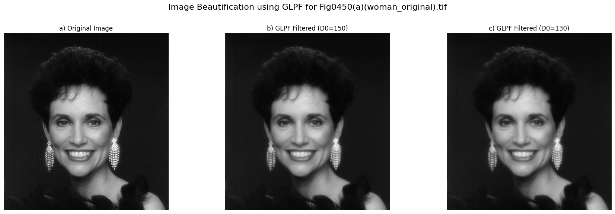

**Homework7: Implement Figure 4.50 by programming with Python**

**Python Code:**

**import** numpy as np

**import** imageio.v2 as imageio

**import** matplotlib.pyplot as plt

**import** os

**def** pad_image_for_dft(image, padding_mode**=**'reflect'):

    """Pads the image to a size suitable for DFT (e.g., 2*M x 2*N)"""

    M, N **=** image.shape

    P, Q **=** 2 **\*** M, 2 **\*** N

    pad_h **=** P **-** M

    pad_w **=** Q **-** N

    padded_image **=** np.pad(image, ((0, pad_h), (0, pad_w)), mode**=**padding_mode)

**return** padded_image, (M, N)

**def** create_gaussian_lowpass_filter(shape, D0):

    """Creates a Gaussian Lowpass Filter (GLPF) in the frequency domain"""

    P, Q **=** shape

    H **=** np.zeros((P, Q), dtype**=**float)

    center_u, center_v **=** P **/** 2, Q **/** 2

    u_coords **=** np.arange(P) **-** center_u

    v_coords **=** np.arange(Q) **-** center_v

    U, V **=** np.meshgrid(u_coords, v_coords, indexing**=**'ij')

    D_uv_squared **=** U **\*\*** 2 **+** V **\*\*** 2

**if** D0 **==** 0:

        H **=** np.ones(shape, dtype**=**float)

**else**:

        H **=** np.exp(**-**D_uv_squared **/** (2 **\*** D0 **\*\*** 2))

**return** H

**if** __name__ **==** "__main__":

    input_dir **=** "original_image"

    output_dir **=** "output_image"

    os.makedirs(output_dir, exist_ok**=**True)

    image_filename **=** "Fig0451(a)(satellite_original).tif"

    image_path **=** os.path.join(input_dir, image_filename)

    base_name **=** os.path.splitext(image_filename)[0]

    original_image **=** imageio.imread(image_path)

    original_M, original_N **=** original_image.shape

    padded_image, _ **=** pad_image_for_dft(original_image, padding_mode**=**'reflect')

    P, Q **=** padded_image.shape

    dft_original **=** np.fft.fft2(padded_image.astype(float))

    centered_dft **=** np.fft.fftshift(dft_original)

    D0_values **=** [50, 20]

    filtered_images **=** {}

**for** D0 **in** D0_values:

        H **=** create_gaussian_lowpass_filter((P, Q), D0)

        filtered_dft **=** centered_dft **\*** H

        idft_shifted **=** np.fft.ifftshift(filtered_dft)

        filtered_image_complex **=** np.fft.ifft2(idft_shifted)

        filtered_image **=** np.real(filtered_image_complex)[0:original_M, 0:original_N]

        filtered_image **=** np.clip(filtered_image, 0, 255).astype(np.uint8)

        filtered_images[D0] **=** filtered_image

    plt.figure(figsize**=**(18, 6))

    plt.suptitle(f'GLPF for Satellite Image (Fig 4.50) - {image_filename}', fontsize**=**16)

    plt.subplot(1, 3, 1)

    plt.imshow(original_image, cmap**=**'gray', vmin**=**0, vmax**=**255)

    plt.title('a) Original Satellite Image')

    plt.axis('off')

    plt.subplot(1, 3, 2)

    plt.imshow(filtered_images[50], cmap**=**'gray', vmin**=**0, vmax**=**255)

    plt.title(f'b) GLPF Filtered (D0=50)')

    plt.axis('off')

    plt.subplot(1, 3, 3)

    plt.imshow(filtered_images[20], cmap**=**'gray', vmin**=**0, vmax**=**255)

    plt.title(f'c) GLPF Filtered (D0=20)')

    plt.axis('off')

    plt.tight_layout(rect**=**[0, 0.03, 1, 0.95])

    combined_output_path **=** os.path.join(output_dir, f"{base_name}_glpf_satellite_results.png")

    plt.savefig(combined_output_path, bbox_inches**=**'tight')

    plt.close()

**Processed Images:**

